Project Planning Phase
Project Planning Template (Product Backlog, Sprint Planning, Stories, Story points)

Date
Team ID | SWTID-2026-6947
Project Name | AI FAQ Assistant API
Maximum Marks | 5 Marks

Product Backlog, Sprint Schedule, and Estimation (4 Marks)
Use the below template to create product backlog and sprint schedule
Sprint | Functional Requirement (Epic) | User Story Number | User Story / Task | Story Points | Priority | Team Members
Sprint-1 | Project Setup & Authentication | USN-01 | As a developer, I can initialize the Node.js/Express backend and organize the source code into a maintainable project structure. | 3 | High | Keerthana S.; Nandhini A.; Tamizharasu P.; Shamini S.
Sprint-1 | Project Setup & Authentication | USN-02 | As a user, I can register with my name, email, and password so that my account is created securely. | 3 | High | Keerthana S.; Nandhini A.; Tamizharasu P.; Shamini S.
Sprint-1 | Project Setup & Authentication | USN-03 | As a registered user, I can log in with my email and password so that I can access authenticated features. | 3 | High | Keerthana S.; Nandhini A.; Tamizharasu P.; Shamini S.
Sprint-1 | Project Setup & Authentication | USN-04 | As an authenticated user, I receive a JWT token and protected routes verify the token before granting access. | 4 | High | Keerthana S.; Nandhini A.; Tamizharasu P.; Shamini S.
Sprint-1 | Project Setup & Authentication | USN-05 | As a system, I can hash passwords with bcrypt and validate request data to protect user credentials and data integrity. | 3 | High | Keerthana S.; Nandhini A.; Tamizharasu P.; Shamini S.
Sprint-1 | Project Setup & Authentication | USN-06 | As a user, I can access my profile information through an authenticated API endpoint. | 2 | Medium | Keerthana S.; Nandhini A.; Tamizharasu P.; Shamini S.
Sprint-1 | Project Setup & Authentication | USN-07 | As a system, I can return consistent errors through centralized error handling for invalid or failed requests. | 2 | High | Keerthana S.; Nandhini A.; Tamizharasu P.; Shamini S.
Sprint-2 | FAQ Management & Search | USN-08 | As a content creator, I can create an FAQ with a question, answer, category, and creator information. | 3 | High | Keerthana S.; Nandhini A.; Tamizharasu P.; Shamini S.
Sprint-2 | FAQ Management & Search | USN-09 | As a user, I can view published FAQs and retrieve a specific FAQ by its ID. | 2 | High | Keerthana S.; Nandhini A.; Tamizharasu P.; Shamini S.
Sprint-2 | FAQ Management & Search | USN-10 | As a content creator, I can update my FAQ so that incorrect or outdated information can be corrected. | 3 | High | Keerthana S.; Nandhini A.; Tamizharasu P.; Shamini S.
Sprint-2 | FAQ Management & Search | USN-11 | As an authorized user, I can delete an FAQ so that obsolete content can be removed. | 2 | Medium | Keerthana S.; Nandhini A.; Tamizharasu P.; Shamini S.
Sprint-2 | FAQ Management & Search | USN-12 | As a content creator, I can organize FAQs into categories for easier navigation and management. | 3 | Medium | Keerthana S.; Nandhini A.; Tamizharasu P.; Shamini S.
Sprint-2 | FAQ Management & Search | USN-13 | As a user, I can search FAQs using keywords so that I can find relevant information quickly. | 3 | High | Keerthana S.; Nandhini A.; Tamizharasu P.; Shamini S.
Sprint-2 | FAQ Management & Search | USN-14 | As an administrator, I can manage FAQ access using role-based permissions. | 2 | High | Keerthana S.; Nandhini A.; Tamizharasu P.; Shamini S.
Sprint-2 | FAQ Management & Search | USN-15 | As a public user, I can access published FAQ content without accessing protected API operations. | 2 | Medium | Keerthana S.; Nandhini A.; Tamizharasu P.; Shamini S.
Sprint-3 | AI-Powered FAQ Assistance | USN-16 | As a system, I can connect securely to Google Gemini AI so that AI-assisted FAQ services are available through the backend. | 4 | High | Keerthana S.; Nandhini A.; Tamizharasu P.; Shamini S.
Sprint-3 | AI-Powered FAQ Assistance | USN-17 | As a content creator, I can generate FAQ questions and answers from a supplied topic using Google Gemini AI. | 5 | High | Keerthana S.; Nandhini A.; Tamizharasu P.; Shamini S.
Sprint-3 | AI-Powered FAQ Assistance | USN-18 | As an authenticated user, I can request an AI-assisted answer to support customer questions. | 4 | High | Keerthana S.; Nandhini A.; Tamizharasu P.; Shamini S.
Sprint-3 | AI-Powered FAQ Assistance | USN-19 | As a content creator, I can receive AI-generated topic suggestions to help organize or expand FAQ content. | 3 | Medium | Keerthana S.; Nandhini A.; Tamizharasu P.; Shamini S.
Sprint-3 | AI-Powered FAQ Assistance | USN-20 | As an administrator, I can monitor AI-generated content before it is used as managed FAQ information. | 2 | Medium | Keerthana S.; Nandhini A.; Tamizharasu P.; Shamini S.
Sprint-3 | AI-Powered FAQ Assistance | USN-21 | As a system, I can validate AI service requests and handle AI-service failures with standardized API responses. | 2 | High | Keerthana S.; Nandhini A.; Tamizharasu P.; Shamini S.
Sprint-4 | Testing, Quality & Delivery | USN-22 | As a developer, I can test registration, login, FAQ CRUD, search, and AI endpoints using Postman or ThunderClient. | 4 | High | Keerthana S.; Nandhini A.; Tamizharasu P.; Shamini S.
Sprint-4 | Testing, Quality & Delivery | USN-23 | As a user, I can perform keyword and semantic FAQ searches and receive relevant results. | 4 | High | Keerthana S.; Nandhini A.; Tamizharasu P.; Shamini S.
Sprint-4 | Testing, Quality & Delivery | USN-24 | As a system, I can enforce Mongoose schemas and validation rules across user and FAQ data. | 3 | High | Keerthana S.; Nandhini A.; Tamizharasu P.; Shamini S.
Sprint-4 | Testing, Quality & Delivery | USN-25 | As a developer, I can verify protected routes, role-based access, and authentication failures through API tests. | 3 | High | Keerthana S.; Nandhini A.; Tamizharasu P.; Shamini S.
Sprint-4 | Testing, Quality & Delivery | USN-26 | As a developer, I can run the backend with the npm development command and access the API through an API client. | 2 | Medium | Keerthana S.; Nandhini A.; Tamizharasu P.; Shamini S.
Sprint-4 | Testing, Quality & Delivery | USN-27 | As a project team, we can maintain API documentation, demo material, and a GitHub repository for project delivery. | 2 | Medium | Keerthana S.; Nandhini A.; Tamizharasu P.; Shamini S.
Sprint-4 | Testing, Quality & Delivery | USN-28 | As a system, I can provide standardized JSON responses and centralized error handling across the API. | 2 | High | Keerthana S.; Nandhini A.; Tamizharasu P.; Shamini S.

Project Tracker, Velocity & Burndown Chart: (4 Marks)
Sprint | Total Story Points | Duration | Sprint Start Date | Sprint End Date (Planned) | Story Points Completed (as on Planned End Date) | Sprint Release Date (Actual)
Sprint-1 | 20 | 10 Days | 01 Oct 2026 | 10 Oct 2026 | To be updated | To be updated
Sprint-2 | 20 | 10 Days | 11 Oct 2026 | 20 Oct 2026 | To be updated | To be updated
Sprint-3 | 20 | 10 Days | 21 Oct 2026 | 30 Oct 2026 | To be updated | To be updated
Sprint-4 | 20 | 10 Days | 31 Oct 2026 | 09 Nov 2026 | To be updated | To be updated

Velocity:
For this project, each sprint is planned for 10 days and the target velocity is 20 story points per sprint. The average velocity per day is calculated as: AV = 20 story points / 10 days = 2 story points per day.


Burndown Chart:
A burn down chart is a graphical representation of work left to do versus time. It is often used in agile software development methodologies such as Scrum. However, burn down charts can be applied to any project containing measurable progress over time.

https://www.visual-paradigm.com/scrum/scrum-burndown-chart/
https://www.atlassian.com/agile/tutorials/burndown-charts

Reference:
https://www.atlassian.com/agile/project-management
https://www.atlassian.com/agile/tutorials/how-to-do-scrum-with-jira-software
https://www.atlassian.com/agile/tutorials/epics
https://www.atlassian.com/agile/tutorials/sprints
https://www.atlassian.com/agile/project-management/estimation
https://www.atlassian.com/agile/tutorials/burndown-charts

Project tracking assumption: 80 total planned story points (20 per sprint) over four 10-day sprints. Actual completed points should be updated at each daily stand-up/review.
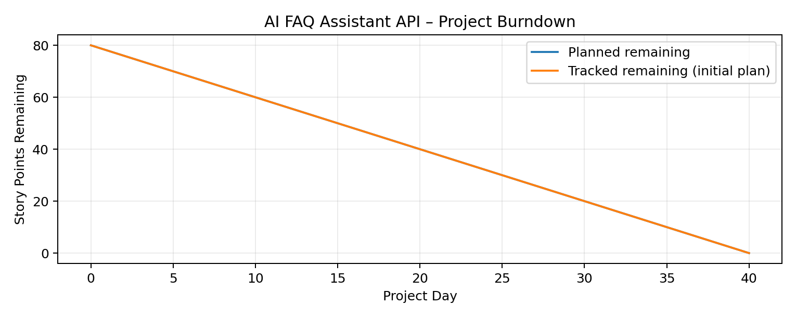
Project Deliverables: Demo video and GitHub repository are available in the source API documentation.

